Republic of Iraq
Al-Nahrain University
College of Science

Computer Science
Stage Three
Software Engineering
Food Ordiring Report

Supervising : Dr. Najwan Abd
Name : Ahmed Jamal, Ameer Hassan

1. Introduction

The Food Ordering & Delivery System is a desktop application developed using C# Windows Forms and MySQL as the backend database. The system enables customers to browse restaurant menus, place food orders, and track their delivery status in real time. It supports four distinct user roles — Admin, Restaurant Staff, Customer, and Driver — each with a dedicated interface tailored to their responsibilities.

This report covers the software engineering aspects of the project: the system architecture, class and module design, data flow, security considerations, real-time update mechanisms, and interface design patterns. The goal is to document the engineering decisions made throughout the development lifecycle.

2. System Overview

2.1 Purpose and Scope
The system addresses the problem of manual food ordering by providing a structured digital platform. It covers the full lifecycle of a food order: customer registration and login, menu browsing, cart management, order placement, kitchen preparation tracking, driver assignment, and delivery confirmation.

2.2 Technology Stack
Component | Technology
Language | C# (.NET 10 Windows Forms)
IDE | Visual Studio 2022
Database | MySQL (via MySQL Workbench)
Data Access | MySql.Data Connector/NET (NuGet package)
UI Framework | Windows Forms (WinForms) with custom dark theme
Architecture | Layered: UI Forms → DatabaseHelper → MySQL
Version Control | Git (project zipped for submission)

2.3 User Roles

Role | Responsibilities
Admin | Full system control: manages restaurants, hires/removes staff and drivers, oversees all orders and deliveries, assigns drivers to orders.
Staff | Accesses the Admin Dashboard with the same privileges (shares the same form, differentiated by the Role column in the database).
Customer | Registers, browses menu by restaurant, manages a shopping cart, places orders, and tracks order status in real time.
Driver | Views and manages their own assigned deliveries; marks orders as Delivered.

3. Software Architecture

3.1 Architectural Pattern
The system follows a two-tier client-server architecture with a clear separation between the presentation layer (Windows Forms) and the data layer (MySQL). The DatabaseHelper static class acts as the service layer, isolating all data access logic from the UI forms. This separation improves maintainability and makes future refactoring straightforward.

The layered breakdown is:
- Presentation Layer — Windows Forms classes (Login, AdminDashboard, CustomerInterface, DriverDashboard, RegisterForm)
- Service / Data Access Layer — DatabaseHelper.cs (static class with all SQL execution methods)
- Database Layer — MySQL server accessed via the MySQL Workbench connection string format

3.2 Module Breakdown

File / Class | Responsibility
Program.cs | Entry point. Initialises the Windows Forms application and launches the Login form.
Login.cs | Authentication form. Validates credentials, identifies user role, and routes to the correct dashboard.
RegisterForm.cs | Self-registration form for new customers. Inserts into both Users and Customer tables in a transaction.
AdminDashboard.cs | Multi-tab admin interface. Manages restaurants, staff, menu items, orders, and deliveries. Includes a 3-second auto-refresh timer.
CustomerInterface.cs | Two-tab customer interface. Tab 1: food card grid with cart and order placement. Tab 2: order history with 3-second auto-refresh.
DriverDashboard.cs | Driver-specific form showing assigned deliveries. Includes a 3-second auto-refresh timer and a Mark Delivered action.
DatabaseHelper.cs | Static data access class. Provides parameterised queries, transactions, and helper methods for all domain objects.
Admin Dashboard.Designer.cs | Auto-generated designer file for AdminDashboard layout (tabControl, DataGridViews, TextBoxes, Buttons).

4. Class Design & Key Patterns

4.1 Static Service Class (DatabaseHelper)
DatabaseHelper is implemented as a static class to provide a single, globally accessible data access point. This avoids the overhead of instantiation and ensures that all database interaction is centralised. It exposes three generic helper methods used by all domain-specific methods:
- ExecuteQuery — returns a DataTable for SELECT statements
- ExecuteNonQuery — executes INSERT, UPDATE, DELETE; returns rows affected
- ExecuteScalar — retrieves a single value (used for LAST_INSERT_ID() and role lookups)

All methods use parameterised queries with MySqlParameter objects, preventing SQL injection attacks entirely.

public static DataTable ExecuteQuery(string sql, params MySqlParameter[] prms)
{
var dt = new DataTable();
using var conn = GetConnection(); // opens, auto-closes
conn.Open();
using var cmd = new MySqlCommand(sql, conn);
cmd.Parameters.AddRange(prms);
using var adapter = new MySqlDataAdapter(cmd);
adapter.Fill(dt);
return dt;
}

4.2 Transaction Pattern
Operations that affect multiple tables (PlaceOrder, RegisterUser, RegisterCustomer) are wrapped in explicit MySQL transactions. If any step fails, the transaction is rolled back to preserve data integrity. This is critical for the order placement workflow which must atomically insert into both Orders and OrderDetails.

using var tx = conn.BeginTransaction();
try {
// Step 1: Insert into Orders
// Step 2: Insert into OrderDetails (loop per cart item)
tx.Commit();
}
catch { tx.Rollback(); throw; }

4.3 Role-Based Routing
After successful login, the Login form reads the Role field returned by the database and routes the user to the correct form using a switch statement. This is a clean implementation of role-based access control (RBAC) at the application level:

switch (role) {
case "Admin": case "Staff":
new AdminDashboard(userId).ShowDialog(); break;
case "Customer":
new CustomerInterface(userId).ShowDialog(); break;
case "Driver":
new DriverDashboard(userId).ShowDialog(); break;
}

4.4 Partial Class Pattern (WinForms)
All forms that use the Visual Studio Designer (Login, AdminDashboard, CustomerInterface) are implemented as partial classes. The auto-generated designer code lives in the .Designer.cs file, while business logic lives in the main .cs file. This is a standard WinForms pattern that separates auto-generated UI wiring from hand-written application logic.

4.5 Timer-Based Auto-Refresh
A key engineering decision was to add real-time data synchronisation using System.Windows.Forms.Timer. Each dashboard subscribes a tick handler that re-queries the database every 3,000 milliseconds and updates the relevant DataGridView. The timer is stopped when the form closes to prevent cross-thread exceptions and resource leaks:

private readonly System.Windows.Forms.Timer _refreshTimer
= new() { Interval = 3000 };

_refreshTimer.Tick += RefreshTimer_Tick;
_refreshTimer.Start();
this.FormClosed += (s, e) => _refreshTimer.Stop();

The AdminDashboard timer is context-aware: it reads tabControl1.SelectedIndex and only refreshes the data for the tab currently visible to the user, avoiding unnecessary database calls for hidden tabs.

5. Data Flow

5.1 Login Flow
- User enters email, password, and role on the Login form.
- btnLogin_Click calls DatabaseHelper.ValidateLogin(email, password).
- DatabaseHelper executes a parameterised SELECT on the Users table.
- If a match is found, the Role string is returned; otherwise null.
- The form routes to the appropriate dashboard using a switch on role.
- The user's database Id is retrieved via DatabaseHelper.GetUserId(email) and passed to the dashboard constructor for scoped queries.

5.2 Order Placement Flow
- Customer browses food cards (loaded from MenuItem JOIN Restaurant).
- Customer clicks "Add" on a card — item is added to the in-memory Dictionary<int, (Name, Price, Qty)> cart.
- The cart DataGridView is refreshed and the running total is recalculated.
- Customer clicks "Place Order" — the RestId is looked up from the first cart item.
- DatabaseHelper.PlaceOrder() opens a transaction: inserts one Orders row, then one OrderDetails row per cart item.
- On commit, the order ID is returned and shown to the customer. Cart is cleared.
- Admin sees the new order on their Orders tab within ≤3 seconds (timer refresh).
- Admin assigns a driver — DatabaseHelper.AssignDelivery() inserts into Delivery and updates order status to "Out for Delivery".
- Driver sees the assignment within ≤3 seconds on their dashboard. Marks as Delivered.

5.3 Cart Remove Flow
When a customer clicks the "✕ Remove" button column in the cart DataGridView, the hidden ItemId column value is read, the corresponding key is removed from the in-memory cart dictionary, the grid is re-rendered, and the total is recalculated. No database call is made during cart editing — the database is only written on order placement.

6. Security Design
- SQL Injection Prevention — All database queries use MySqlParameter objects. No string concatenation is used to build queries anywhere in the codebase.

- Password Masking — The Login form sets txtPassword.PasswordChar = '*', masking input from shoulder surfing.

- Role-Based Access Control — Each role only sees and interacts with the form built for their role. A Customer cannot access the AdminDashboard; a Driver cannot place orders on behalf of customers.

- Scoped Queries — CustomerInterface passes the logged-in customer's userId to filter queries (GetOrders(custId)). A customer can only see their own orders. DriverDashboard similarly scopes delivery queries to the logged-in driver's id.

- Transaction Atomicity — Multi-table writes use BEGIN TRANSACTION / COMMIT / ROLLBACK, preventing partial data corruption if a network or application error occurs mid-operation.

7. User Interface Design
All forms share a consistent dark theme (RGB 20,20,20 background, gold accent colour), providing a professional, low-eye-strain interface. UI controls are built using WinForms with custom properties applied at runtime where the designer is insufficient.

7.1 Login Form
The entry point of the application. Provides email, password, and role fields with input validation. Includes a register link that opens a modal registration dialog.
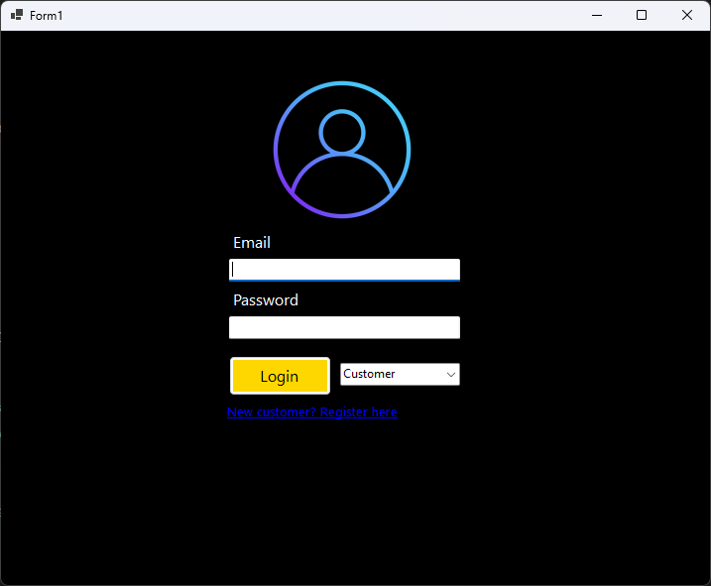
Figure 1 — Login Form

7.2 Customer Registration Form
A modal dialog opened from the Login form's register link. Collects name, email, password, and address. On submission, a database transaction inserts into both the Users and Customer tables atomically.
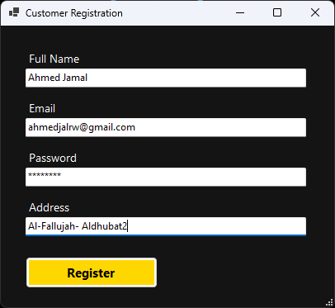
Figure 2 — Customer Registration Form

7.3 Admin Dashboard — Restaurant Management Tab
The first tab of the AdminDashboard. Allows adding, updating, and deleting restaurants. The DataGridView on the right auto-refreshes every 3 seconds showing all restaurants with their assigned admin.
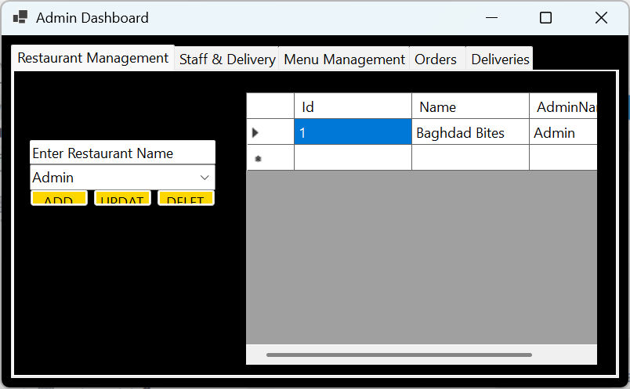
Figure 3 — Admin Dashboard: Restaurant Management Tab

7.4 Admin Dashboard — Staff & Drivers Tab
Allows the admin to register new Staff and Driver users with a single form (the Role dropdown selects the role). The REMOVE button deletes the user from all related tables using cascaded deletes. The grid auto-refreshes every 3 seconds.
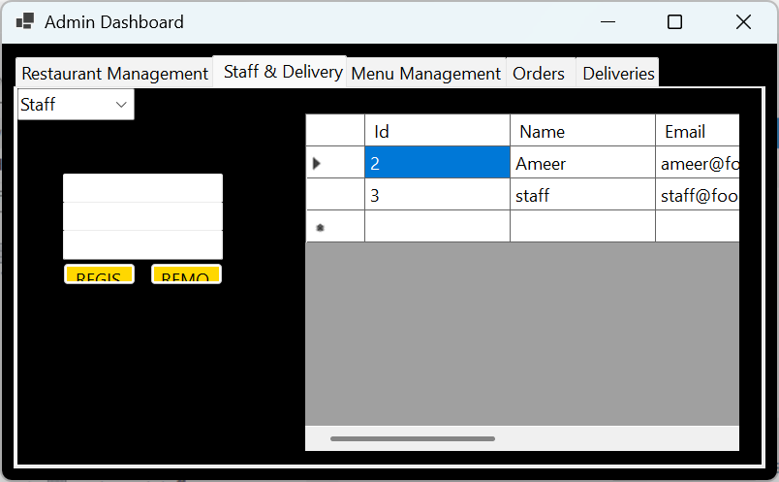
Figure 4 — Admin Dashboard: Staff & Drivers Tab

7.5 Admin Dashboard — Menu Management Tab
Provides CRUD operations for menu items. Each item is linked to a restaurant via the restaurant combo box. Clicking a row in the grid populates the input fields for quick editing.
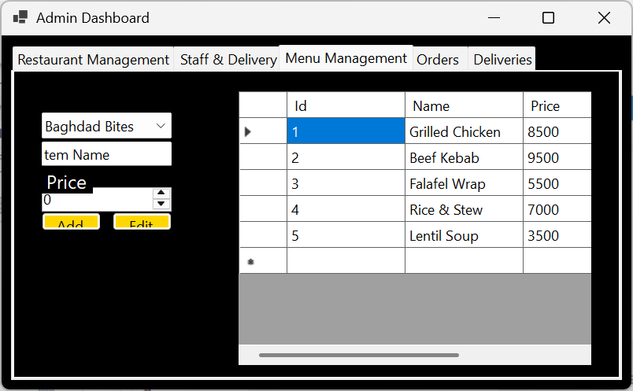
Figure 5 — Admin Dashboard: Menu Management Tab

7.6 Admin Dashboard — Orders Tab
Displays all system orders with live colour-coded statuses (gold for Pending, green for Ready, blue for Out for Delivery, light green for Delivered). The admin can mark orders as Ready and assign a driver from a dropdown. The tab auto-refreshes every 3 seconds.
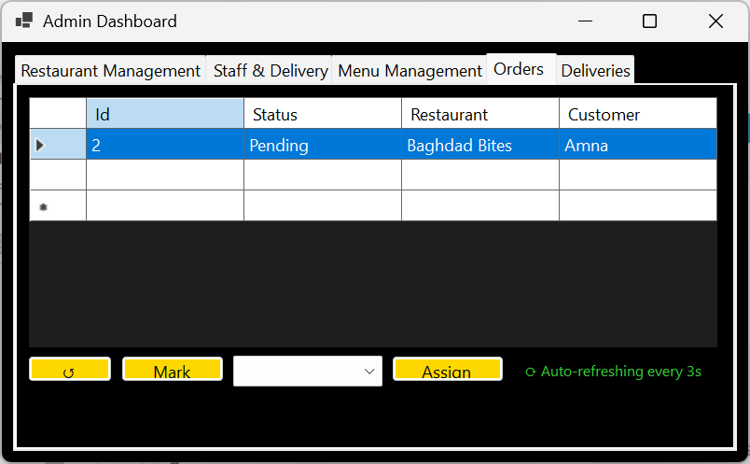
Figure 6 — Admin Dashboard: Orders Tab

7.7 Customer Interface — Menu Tab
Shows food items as interactive cards grouped by restaurant. A filter combo box at the top allows filtering by restaurant. Each card displays item name, restaurant, price, a quantity spinner, and an Add button. The cart panel on the right shows added items with individual Remove buttons, a running total, Place Order, and Clear Cart buttons.
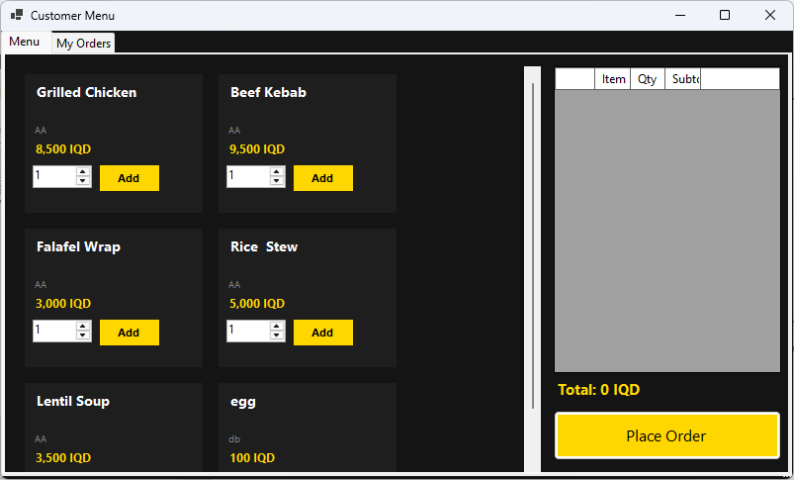
Figure 7 — Customer Interface: Menu & Cart Tab

7.8 Customer Interface — My Orders Tab
Shows the logged-in customer's order history with colour-coded statuses. The tab auto-refreshes every 3 seconds and includes a manual Refresh Now button, allowing the customer to track their delivery without restarting the application.
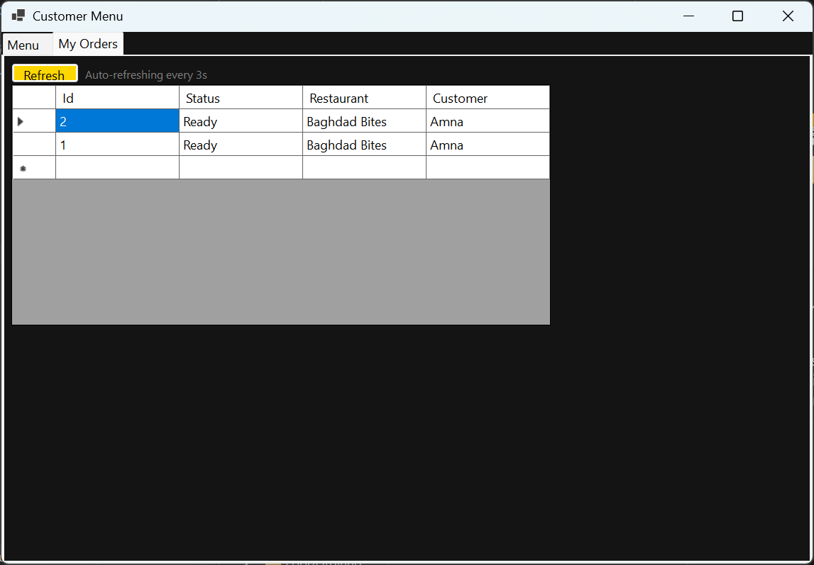
Figure 8 — Customer Interface: My Orders Tab

7.9 Driver Dashboard
Displays only the deliveries assigned to the logged-in driver, filtered by driver ID. The auto-refresh timer updates the grid every 3 seconds so new assignments appear immediately. The Mark Delivered button updates the order status in the database.
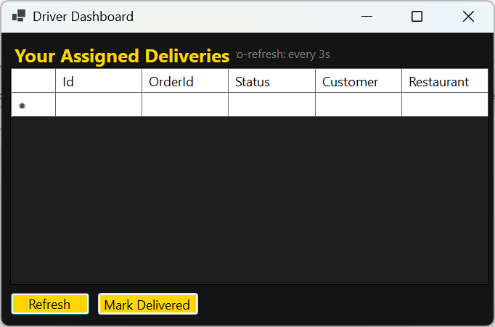
Figure 9 — Driver Dashboard

8. Non-Functional Requirements

Requirement | Implementation
Responsiveness | UI remains responsive during database calls. Timers run on the WinForms UI thread using System.Windows.Forms.Timer (not System.Threading.Timer), which dispatches tick events safely on the UI thread without requiring Invoke().
Data Integrity | Multi-table writes are wrapped in explicit MySQL transactions with rollback on failure.
Security | All queries use parameterised inputs. Role-based routing ensures users only access their designated interface.
Maintainability | All database logic is centralised in DatabaseHelper.cs. UI forms contain no raw SQL. Adding a new query only requires a new method in DatabaseHelper.
Extensibility | New roles or forms can be added by extending the switch statement in Login.cs and adding a new Form class. The DatabaseHelper generic methods (ExecuteQuery, ExecuteNonQuery) handle any new SQL without changes to their signatures.
Real-Time Updates | Auto-refresh timers at 3-second intervals on all three dashboards ensure data consistency without requiring the user to manually refresh.
Usability | Consistent dark theme across all forms. Colour-coded order statuses allow instant visual understanding of system state. Food cards provide a familiar e-commerce browsing experience.

9. Use Case Summary

Use Case | Description
UC-01 Login | All roles enter email + password. System validates and routes to role-specific dashboard.
UC-02 Register | Customer fills registration form. System creates User + Customer records in a transaction.
UC-03 Browse Menu | Customer views food cards, filters by restaurant, selects quantity.
UC-04 Manage Cart | Customer adds items to cart, adjusts quantities, removes individual items, clears all.
UC-05 Place Order | Customer confirms cart. System creates Order + OrderDetails records in a transaction.
UC-06 Track Order | Customer views live order status on My Orders tab (auto-refreshes every 3s).
UC-07 Manage Restaurants | Admin adds, edits, or deletes restaurants from the system.
UC-08 Manage Menu | Admin adds, edits, or removes menu items linked to a restaurant.
UC-09 Manage Staff | Admin registers new Staff/Driver accounts or removes existing ones.
UC-10 Process Order | Admin marks order as Ready; assigns a Driver from the dropdown.
UC-11 Deliver Order | Driver views assigned deliveries, marks order as Delivered.

10. Conclusion

The Food Ordering & Delivery System demonstrates a well-structured C# Windows Forms application built on sound software engineering principles. The separation of concerns between the UI layer and the DatabaseHelper service layer keeps the codebase maintainable and testable. The use of role-based routing, scoped queries, parameterised SQL, and transactional writes addresses the key requirements of security, integrity, and correctness.

The 3-second timer-based auto-refresh mechanism across all three dashboards solves the real-time synchronisation problem without the complexity of multi-threading, by leveraging the WinForms UI-thread-safe timer. The cart design — using an in-memory dictionary with per-row remove buttons — follows the established UX pattern of modern food ordering applications.

Future improvements could include password hashing (e.g., bcrypt), asynchronous database calls using async/await to fully eliminate UI blocking on slow networks, and a notification system to alert drivers of new assignments without requiring them to watch the screen.

